Unit 1 Can you play the guitar?
班级：_____________ 姓名：_____________
Ⅰ.翻译词组
1.参加俱乐部____________ 2.弹钢琴____________ 3.拉小提琴____________
4.夏令营____________ 5.弹吉他____________ 6.摇滚乐队____________
7.天才表演____________ 8.填充，填出____________
Ⅱ.词汇
1.Bethoven is a ____________(音乐家).
2.____________(夏天)is very hot.
3.Do you want to get more ____________(信息)？Look at the poster.
4.Please ____________(联系)Mrs Zhang.
5.Can you____________(弹)the piano?No,I can't.
Ⅲ.选择填空
1.Tom can play ____________ drums very well.
A.a B.an C.the
2.Don't talk ____________ others!Listen to the teacher.
A.for B.to C.on
3.—____________club do you want to join?
—The chess club.
A.Which B.How C.Where
4.They want ____________ buy some tomatoes.
A.and B.or C.to
5.I ____________ play the guitar.It's too difficult.
A.can B.can't C.doesn't
6.What do you have ____________ lunch?
A.at B.on C.for
7.—____________?
—Yes,I want some fruit.
A.Can I help you B.What do you want C.What do you want to buy
8.—____________shop sells ruler?
—____________ next to my home.
A.What;one B.Where;The one C.Which;The one
9.I usually watch TV ____________ Sunday evening.
A.in B.on C.at
Ⅳ.动词填空
1.On weekends I often ____________(go)to the movie with my friends.
2.Can you ____________(swim)in the water?
3.My teacher wants ____________(buy)a pingpong bat.
4.My parents ____________(not eat)salad for breakfast.
5.The shop ____________(have)many clothes.
6.____________ you ____________(want)to join the music club?
7.He can't ____________(play)the piano,but he ____________(play)basketball very well.
8.Let's ____________(clean)our classroom.
9.Where ____________(be)my pants?
10.Hi,Jim!Nice ____________(meet)you.
11.He always ____________(teach)in this room.
12.Many students ____________(be) in the classroom.
Ⅴ.完成句子
1.我的朋友喜欢弹吉他。
My friend likes to ____________ ____________ ____________.
2.我们学校的音乐会是在星期天。
Our ____________ ____________ is on Sunday.
3.你想加入摇滚乐队吗？
Do you____________ to join ____________ ____________?
4.麦克喜欢和我交谈。
Mike likes to ____________ ____________ ____________.
5.我们怎么联系你？
____________ can we ____________ you?
Ⅵ.改错
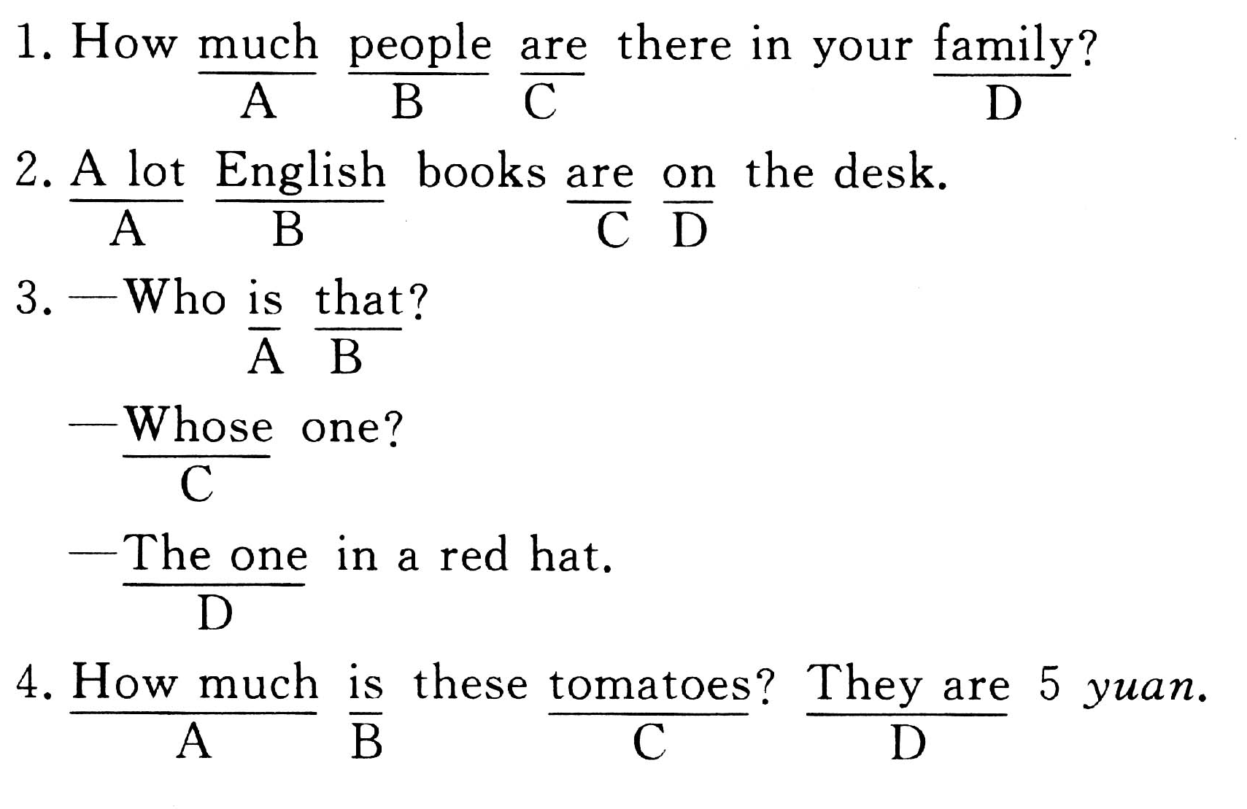
参考答案
Unit 10 Can you play the guitar?
Ⅰ.1.join the club 2.play the piano 3.play the violin 4.summer camping 5.play the guitar 6.a rock band 7.talent show 8.fill in…
Ⅱ.1.musician 2.Summer 3.information 4.contact 5.play
Ⅲ.1~5 CBACB 6~9 CACB
Ⅳ.1.go 2.swim 3.to buy 4.don't eat 5.has 6.Do…want 7.play,plays 8.clean 9.are 10.to meet 11.teaches 12.are
Ⅴ.1.play the guitar 2.school concert 3.want,rock band 4.talk with me 5.How,contact
Ⅵ.1.A—many 2.A—a lot of 3.C—which 4.B—are

